**ECOM90024**

**Forecasting in Economics and Business**

**Tutorial 2 Solutions**

1. Let and be independent discrete random variables. Using an appropriate mathematical derivation, show that

Solution:



1. Let and be independent uniform random variables defined on the interval [0,1]. Let . Compute the following:
3. Download and import the nominal GDP time series data for the United States contained in USGDP.csv and perform the following tasks in R:
4. Generate an appropriate plot of the data and describe, using words, the time series features that are most apparent to you.

For details see R code. The plot should look like this

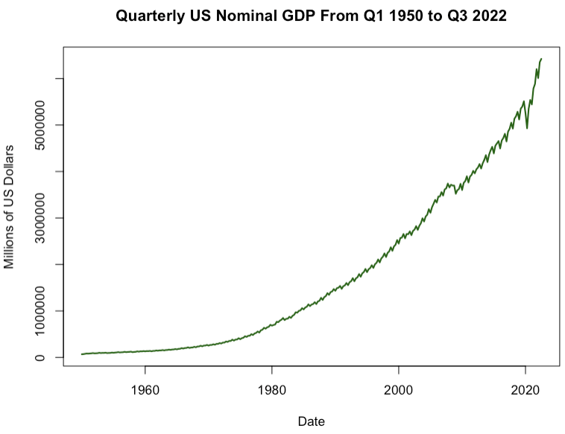

The most obvious time series features are:

* A clear upward trend that is non-linear.
* Some cyclical fluctuations that correspond to the business cycles (i.e., recessions such as the great financial crisis in 2008 and the most recent downturn arising from the pandemic)
* Highly regular seasonal fluctuations corresponding to the quarterly frequency of the series.

1. Estimate an exponential trend model and plot the fitted values along with the original data.

For details, see R code. The plot should look like this:

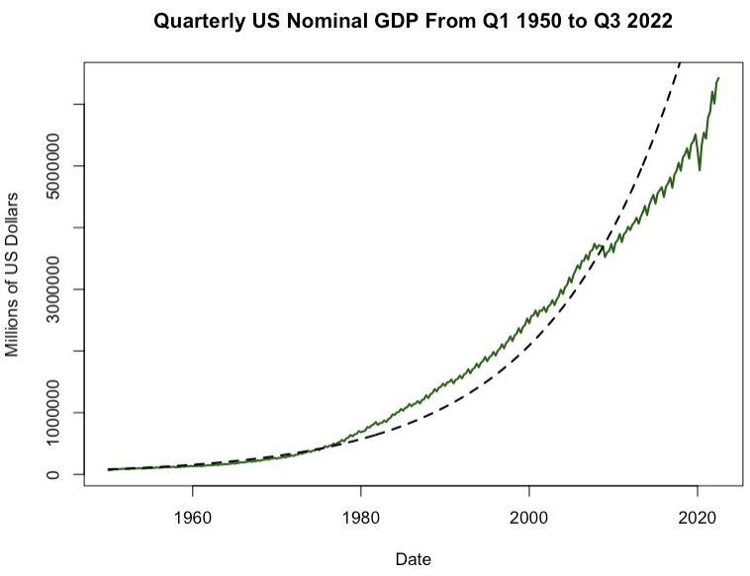

1. Using your estimated results, compute and plot point forecasts for the next 8 quarters ahead along with your original data.

For details, see R code. The plot should look like this:

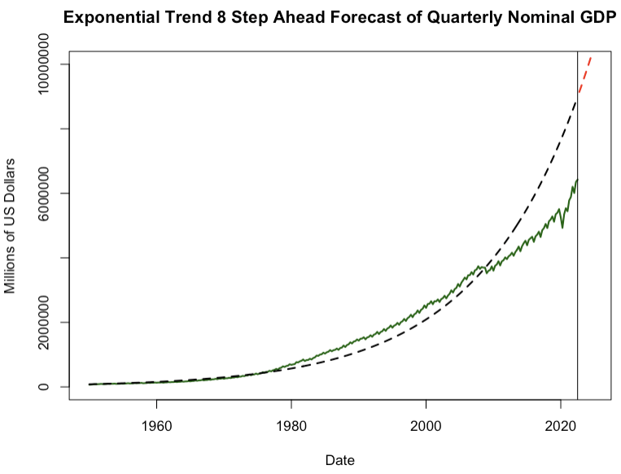

Looking at our results we can see that the exponential trend model does not appear to do a very good job either fitting the data or generating plausible forecasts. This highlights the fact that while deterministic trend models are easy to implement, they often do not do a very good job of capturing long run fluctuations (i.e., they are too restrictive! Most economic and financial time series are not so well behaved!). This motivates us to consider other ways of trend modelling which we will discuss in future lectures.